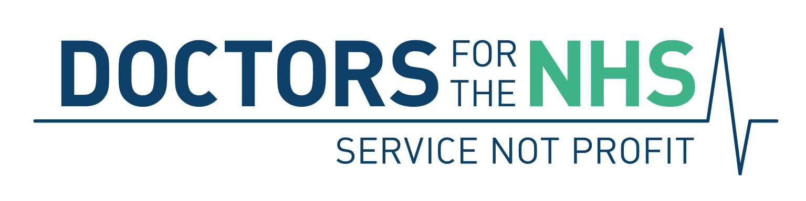

Press Release

6 October 2021

The enemy below: NHS Bill amendment will not prevent private company piracy

The Health Minister’s promise of an amendment to the NHS Bill will not be enough to stop private companies taking part in decisions about NHS budgets and provision of services. Despite government assurances that private companies would not be allowed to sit on or influence the new Integrated Care Boards (ICBs) proposed by the Bill, Doctors for the NHS has learned of a deeper danger, which the government has so far hidden.

The Bill omits key powers of the new statutory Integrated Care Boards - to be inserted by secondary legislation without Parliamentary scrutiny, debate or vote, once the Bill has been enacted, according to "interim guidance" from NHS England.

The new Boards will be responsible for arranging for the provision of almost all NHS services in their geographical area but the Bill omits any mention of their power to delegate their functions. Add to that the fact that NHS England has issued instructions that the Boards' constitutions should include multiple means for delegating their functions to a whole array of unspecified bodies - including Provider Collaboratives, which are also not mentioned in the Bill.

This "interim guidance", issued in August 2021, in particular, August 2021 NHSE interim guidance on Integrated Care Board Governance, says all the ICB delegation of functions will only be legislated for by statutory instrument and statutory guidance – with no Parliamentary scrutiny – if and when the Health & Care Bill is passed and becomes law.

Clinical Commissioning Groups are now steaming ahead with plans for their successor ICBs to delegate lots of their budgets, decision making and contracting to all sorts of bodies and joint committees If it succeeds, this underhand attempt to conceal from lawmakers the power of statutory ICBs to delegate their functions would open the NHS door wider to increased influence from private companies.

DFNHS, along with other health campaigns, is now asking that a further amendment, already drafted, is added to the Bill (See proposed amendment, attached), while it’s still in the Public Bill Committee stage. The amendment would prevent the delegation of powers by statutory Integrated Care Boards and so close this covert ‘back door’ to further, ongoing NHS privatisation. Without such an amendment the Bill, when enacted and extended by secondary legislation, would allow private companies to influence the NHS so that more healthcare ends up in private hands – with public money paying for it. All this with no parliamentary or even public scrutiny and over which Parliament would have absolutely no control.

Mr Colin Hutchinson, a retired Consultant eye surgeon and Chair of DFNHS, said:

‘Yet again, we have to ask: how many times must we call out the hidden dangers of private companies getting their hands on the ability to control NHS budgets and the services on which we all depend? Decisions on how public money is used should not be taken by persons that seek to profit from those decisions. There is no acknowledgment of that possibility by the Government. There seems to be no intention of allowing democratic scrutiny by Parliament. This fuels the suspicion that the vow to “protect the NHS” is nothing more than a cynical slogan. If this is not the intention, it should be easy to put right, now with a simple amendment.”

[Ends]

Editor’s Notes

Doctors for the NHS (DFNHS) was formed in March 2015 by the NHS Consultants’ Association (NHSCA) re-naming itself and asking GPs and medical trainees to join. NHSCA was formed in 1976 and was the oldest continual health-campaigning group with DFNHS’s aims. DFNHS remains the only health-campaign group which admits only qualified doctors. DFNHS has just over 640 members nationwide, most of whom are senior Consultants or retired senior Consultants. Its membership represents many years of experience in the NHS, often at the highest clinical levels. It has the explicit aim of countering marketisation of the NHS by gathering the already impressive evidence; pointing to the ill effects of commercialisation and systematic under-funding on NHS services and founding principles; and campaigning widely to stop then repair the damage before it is too late and cannot be reversed. DFNHS has no partisan political affiliation but often works with other groups and health campaigns to further the crucial message that the NHS should be a publicly funded, publicly accountable and comprehensive service free at point of delivery which cannot be controlled, managed or run by private companies.

DFNHS’s press contact is Alan Taman:
07870 757 309
healthjournos@gmail.com

www.doctorsforthenhs.org
Twitter: https://twitter.com/Doctors4NHS
Facebook: DoctorsForTheNHS

